POLITICAL JUGGERNAUTS : A QUANTATIVE ANALYSIS OF CANDIDAES IN THE 2019 LOK SABHA ELETIONS

INTRODUCTION

Overview

In the introduction of your analysis on the 2019 Lok Sabha elections, you can provide an overview of the political landscape during that time the significance of the elections, and the key candidates and parties involved.

Purpose

The purpose of conducting a quantitative analysis of the candidates inn the 2019 Lok Sabha elections is to provide a rigorous and data-driven understanding of the political dynamics during that significant period.

PROBLEM DEFINITION & DESIGN THINKING

Empathy map

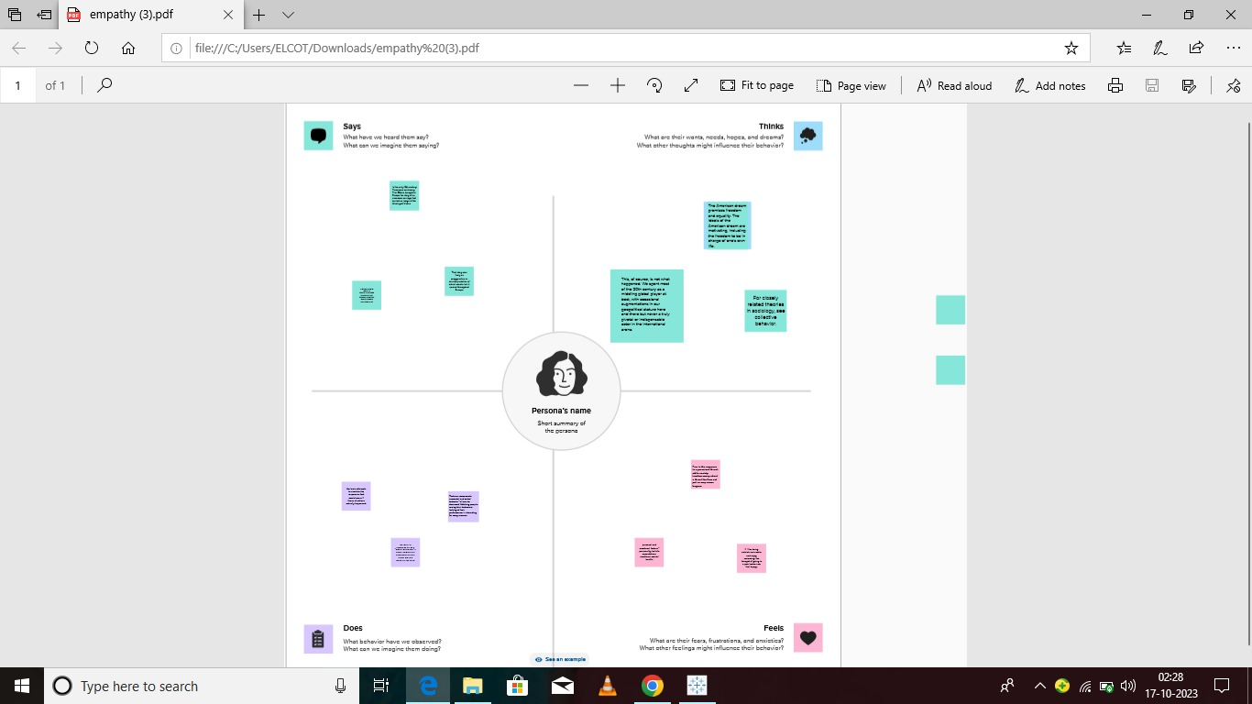

Brainstorm

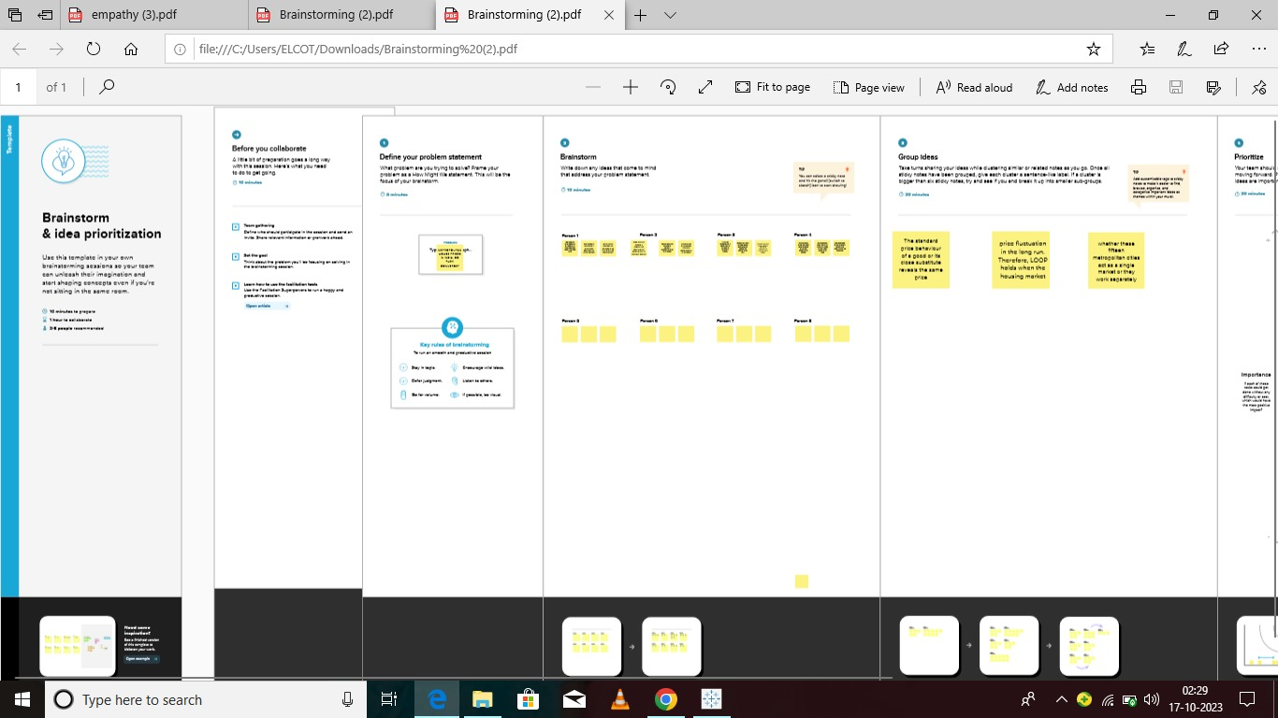

3.RESULT

DASHBOARD

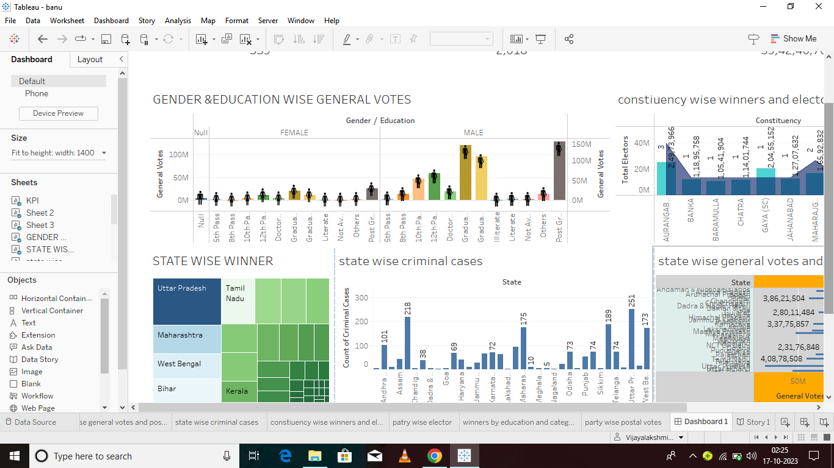

STORY

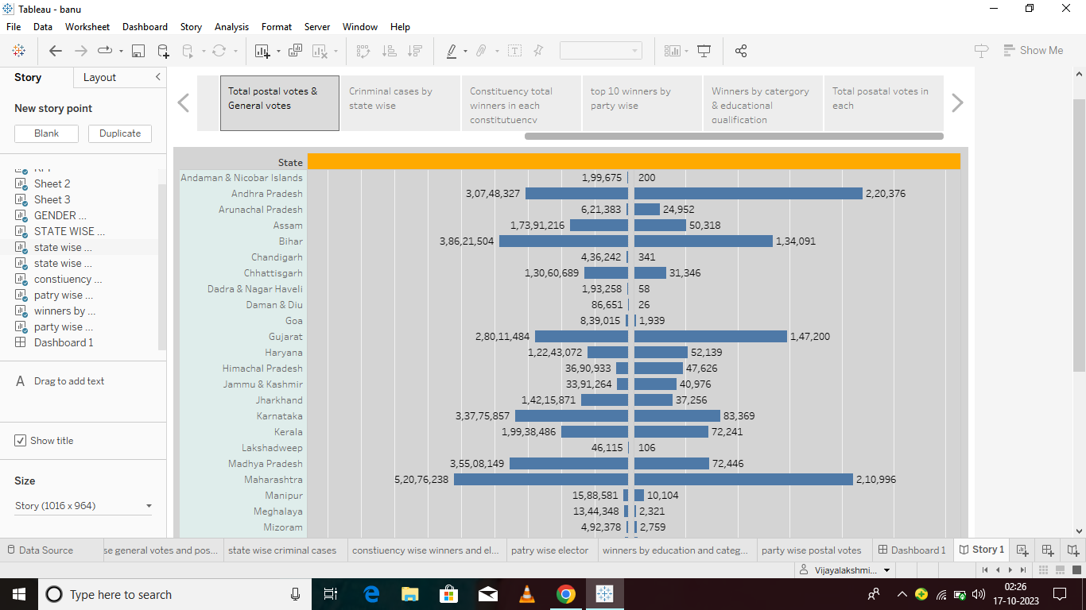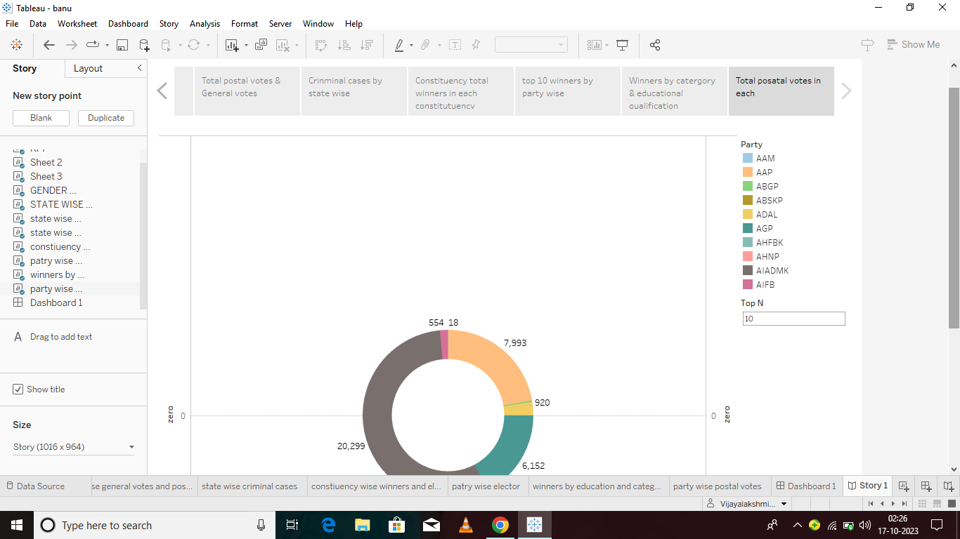

ADVANTAGES & DISADVANTAGES

Advantages

**1. Political parties are able to present political information to the voting population in a manner that is readily understandable.**

**2. Political parties provide balance through the accommodation of various interests and opinions.**

**3. Political parties prevent unexpected shifts in political trends that threaten stability in the government.**

**Disadvantages**

1. **Political parties might have a selfish propaganda that could hurt national interest.**
2. **Political parties could create factionalism.**
3. **Political parties could ruin individuality.**
4. **Political parties could encourage corruption.**

**5.APPLICATION**

'"That after the year sl00 of the Christianl era, there shall be neither Slavery nor inivolunlary servitude in ally of the said States, otherwise than in the punishment of crimes whereof the party shall lhive been duly convicted to have been I ersonally guilty." —4 Jour. Cong. Confederation, 374. Territories were in this articl e of the Ordinance spoken of as States, because it was contemplated to erect the Territories into States. Under the Articles. of Confederation, a majority of the thirteen States was necessary to an affirmative decision of any question. On the 19th, of April a vote was taken on this proviso.

**6.CONCLUSION**

The Lok Sabha is composed of representatives of people chosen by direct election on the basis of Universal Adult Suffrage. The Constitution of India allows for a maximum of 550 members in the House, with 530 members representing the States and 20 representing the Union Territories. The 17th Lok Sabha was formed by the members elected in the 2019 Indian general election.

**7.FUTURE SCOPE**

Thus the legislation of the General Government for more than half a century furnishes a prece dent, in strict conformity,with the platform of the Republican party, on the right of Congress to interdict Slaver- in the national domain. If, then, t~.e Republican party are to be denounced as seciional, on account of entertaining and defending these time-honored doctrines, then the revolutionary heroes were sectional-the signers of the Declaration of Independence were sectional-that immortal instrument was itself sectional-the fi'r:tners of the Constitution were sectional, and so is the Constitution itself.